<https://public.tableau.com/profile/shahrukh7127#!/vizhome/India_FDI_Analysis/TrendForecast?publish=yes>

-- uploading the csv file

-- deleting blank columns and rows using 'Data Interpreter'

-- Using the filter option filtered the total sector row at the bottom

-- Using pivot to turn the entire table

-- Rename the pivot names (2nd column to years, 3rd column to FDI Value)

(little more freedom to play around with the data)

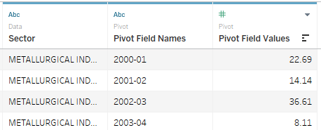

-- Creating a new the Year column

LEFT((YEAR, 4)) Creates a new column with the year only

-- Hide the Year column

QUESTIONS

1. Which sector receives the maximum direct funding for a given year?

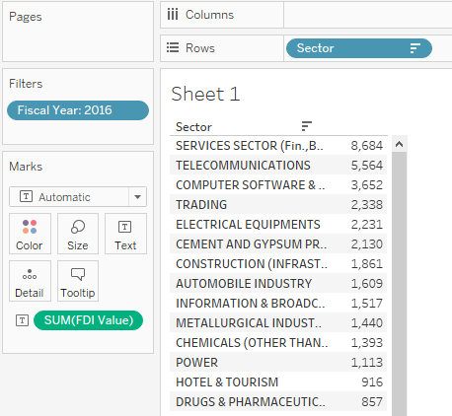

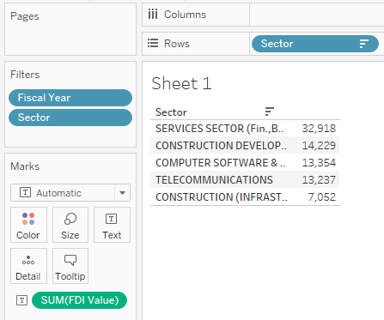

Placing the Sector in Rows and Fiscal year beside the sector column. Adding filter Fiscal year 2016 and sorting it in descending we get the first five direct funding categories.

1. Which sector receives the minimum direct funding for a given year?

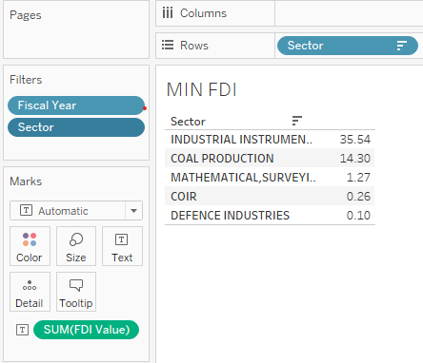

1. Is there a trend for direct investments for individual sectors?

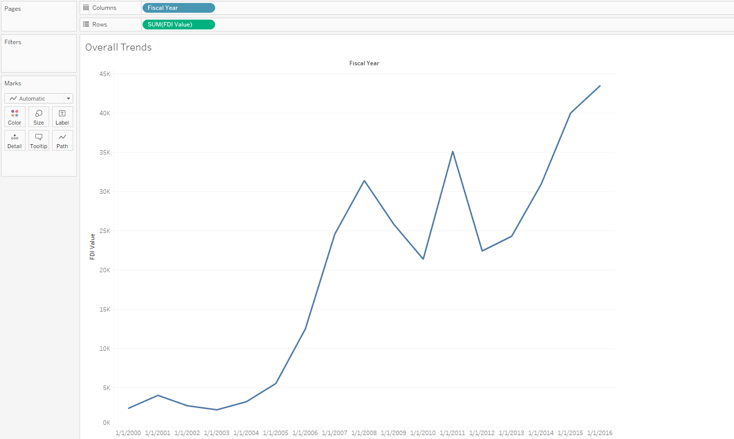

1. In what fashion can the sectors be grouped for comparison?

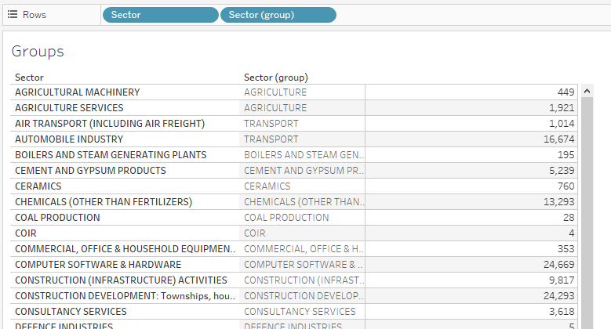

1. Which sectors reported the highest growth in the past 5 years?

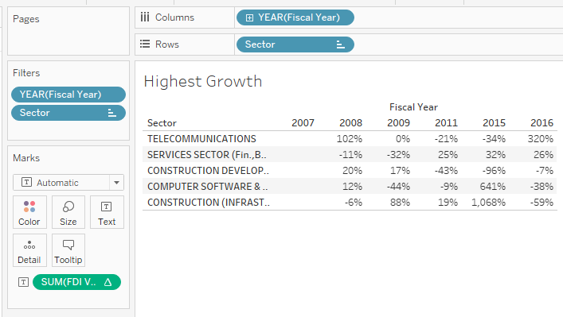

1. Which sectors reported the highest decline in the past 5 years?

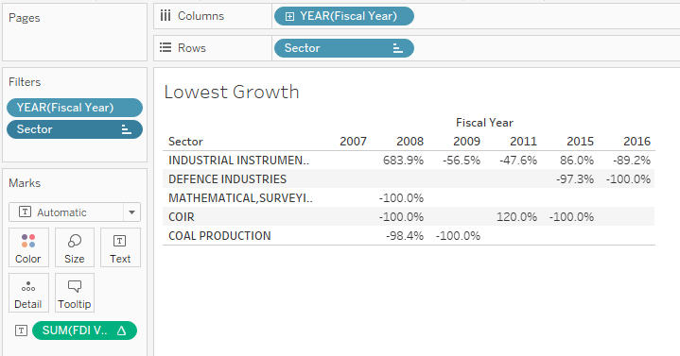

1. Which sectors reported the most variation overall?

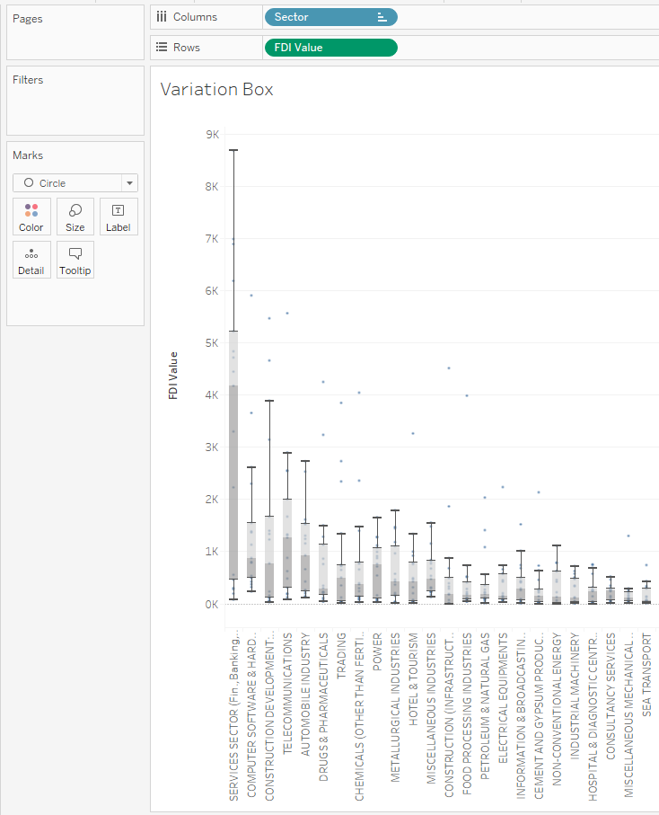

1. What is the proportion of investment between sectors from the FDI perspective?

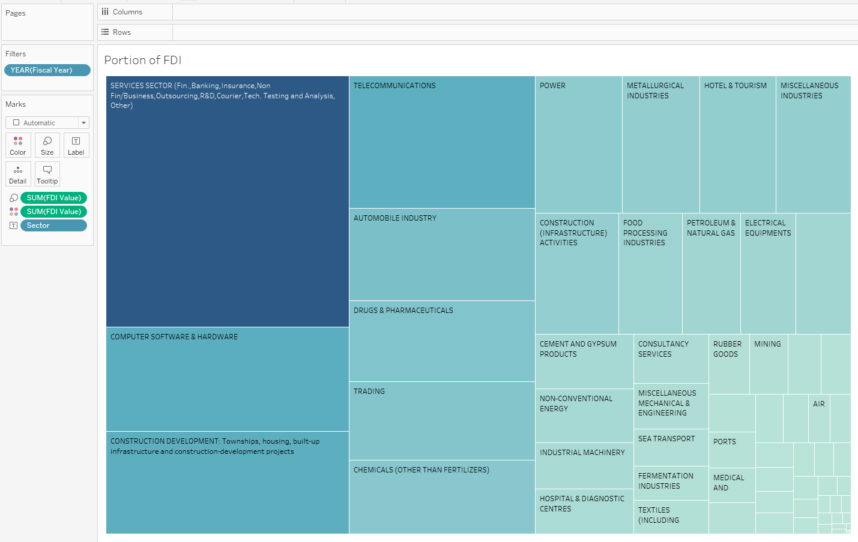

1. Are there any specific clusters present in the data?

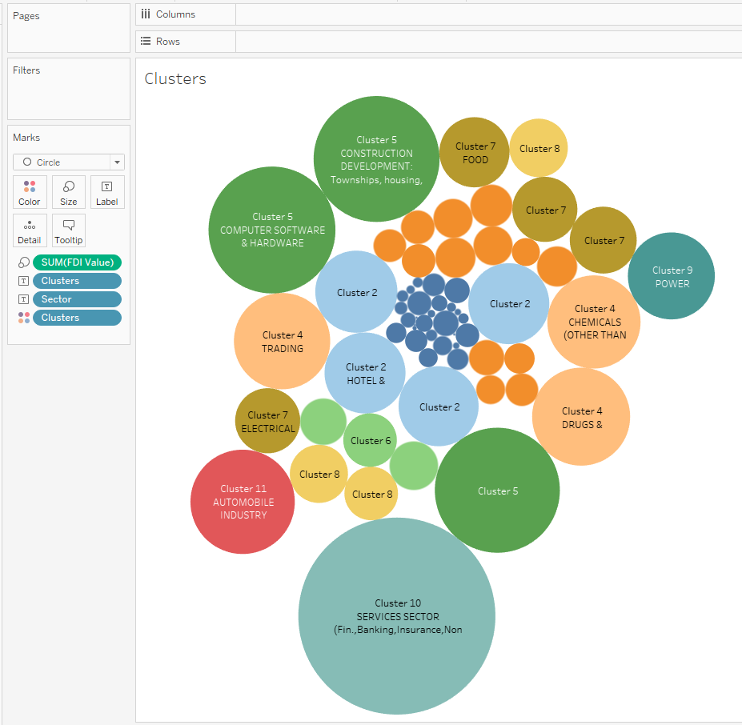

1. Can we forecast the trend for the following year?

